
School of Computer Science and Engineering
Winter Semester 2022-2023
Continuous Assessment Test – 1
SLOT: C1 + TC1
Programme Name &Branch: B.Tech – Computer Science and Engineering
Course Name & code: Data Structures and Algorithms - BCSE202L
Class Number (s): VL2022230505829, VL2022230505831, VL2022230505834, VL2022230505836
VL2022230505857, VL2022230505859, VL2022230505861, VL2022230505953, VL2022230505956, VL2022230506218, VL2022230506305, VL2022230506315, VL2022230507612
Duration: 90 Min. Maximum Marks: 50
Answer all questions
Q.No. | Question | Max Marks | CO | BL
1. | a) Solve the following recurrence equation using Master Theorem  T(n) = T(n/2) + 1, where n=2^{k} for all k>=0  Ans: O(log n)  b) Solve the following equation using the substitution method or Iterative (Back substitution method) T(n) = T(n/3) + T(2n/3) + cn where c is a constant and n is the input size.  Ans: O(nlogn) | 3 Marks  7 Marks | CO1 | BL3
2. | a) Solve the following recurrence equation using the recursive tree method  T(n) = 3T(n/4) + cn^{2,} where c is a constant and n is the input size.  Ans: O(n²)  b) Consider the following code snippet. Find the time complexity of the code. Assume the code is free from any syntax error and is running properly.  int j = 0;  for (i=0; j≤ n; i++)  {  j=i+j;  printf(“I am a student of VIT”);  }  Ans: k^2 is n, implies k=root(n). So, T(n)=O(root(n)) | 7 Marks  3 Marks | CO1 | BL2
3. | Convert the given infix expression into postfix expressions using stack. Explain the step-by-step process.  A + ( B*C – (D / E^F) * G ) * H  Ans: ABC*DEF^/G*-H*+  Step by step process of stack implementation is required | 10 Marks | CO2 | BL5
4. | a) A Circular Queue has a size of 5 and has elements 10, 20 and 40 where F=2 and R=4. After inserting 50 and 60, what is the value of F and R. Trying to insert 30 at this stage, what happens? Delete 2 elements from the Queue and insert 70, 80, 90. Show the sequence of steps with necessary diagrams with the value of F and R  Ans:  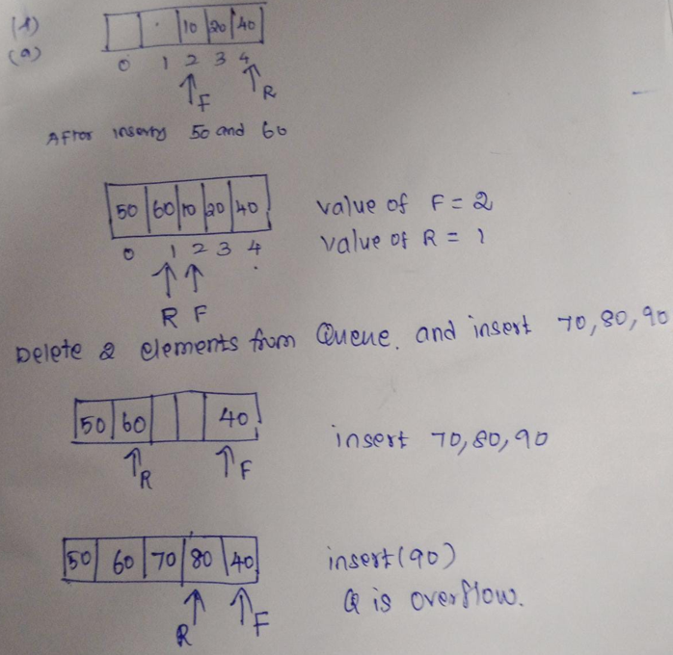  b) Write an algorithm to perform dequeue operation and show the implementation using an array.  Ans:  Step 1 − Check if the queue is empty.  Step 2 − If the queue is empty, produce underflow error and exit.  Step 3 − If the queue is not empty, access the data where front is pointing.  Step 4 − Increment front pointer to point to the next available data element.  Step 5 − Return success | 6 Marks  4 Marks | CO2 | BL3  BL1
5. | Sort the given string and show the intermediate results (step by step) using selection sort. ‘P’ ‘R’ ‘O’ ‘U’ ‘D’ ‘T’ ‘O’ ‘B’ ‘E’ ‘A’ ‘V’ ‘I’ ‘T’ ‘I’ ‘A’ ‘N’  Ans:  ‘A,’ ‘A,’ ‘B,’ ‘D,’ ‘E,’ ‘I,’ ‘I,’ ‘N,’ ‘O’, ‘U,’ ‘P,’ ‘R.’ ‘T’, ‘T, ’ ‘U, ’ ‘V’  Step-by-step selection process iteration is required in the answer script | 10 Marks | CO3 | BL3

